Lesson 2 – The meaning of the problem

What is a problem?
What is data?
What is information?
What steps need to be taken to resolve a problem.
What is algorithm.

What students should know
1h

The concept of the problem
Every day in our lives we have problems. Simple problems of everyday life and often even bigger. As a problem we usually define a situation that we are experiencing and which makes it difficult for us to deal with it or solve.
When we are thinking about a problem these are steps become unconscious in our minds:
- Understanding the problem
- Searching for a solution or set of solutions.
- Choosing the right solution
- Implementing the solution
- Checking whether this solution had the desired results.

Understanding the problem
Understanding the problem is the first step in designing and solving a problem. It is a particularly critical stage because this will also affect the development of the solution. Includes the following steps:
- Description of the problem
The description of the problem is usually done by ourselves or someone who has it. In this step it is important to clarify all its 'dark' points and to have no doubt as to its wording.
- Find the data.
Finding the data means what these elements are based on in order to solve a problem, for example in an equation ax + b = 0 data are the factors a and b.
- Find the requested.
The information that we need to find to deal with the problem. Continuing the previous example information is the x of the equation ax+b=0.

Searching for a solution or set of solutions.
Once we have recognised the data and what is requested, a solution must be found to solve the problem. Often that's not easy. Thus, it is necessary to look for a method or a logical set of steps leading to the solution. These steps must lead to a solution whenever the same problem arises and, moreover, be done in a relatively short period of time.
In mathematics and computer science, an algorithm is a finite sequence of well-defined, computer-implementable instructions, typically to solve a class of problems or to perform a computation.

Choosing the right solution
Often a problem can have more than one solution or some of them may be more efficient than others. Choosing the solution correctly leads to a shorter and more reliable outcome.

Implementing the solution
After the resolution method is selected, a series of actions must be taken to implement it. In other words, apply the Algorithm.

Checking whether this solution had the desired results.
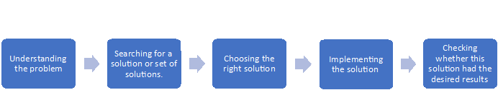
Finally, after applying the solution it is necessary to test with various data, to examine whether it leads to correct results each time it is performed without problematic situations.
Picture 1 The steps

